# *IONIC practical 1*

## *What is a hybrid app?*

#### Like native apps, run on the device, and are written with web technologies (HTML5, CSS and JavaScript). Hybrid apps run inside a native container, and leverage the device’s browser engine (but not the browser) to render the HTML and process the JavaScript locally. A web-to-native abstraction layer enables access to device capabilities that are not accessible in Mobile Web applications, such as the accelerometer, camera and local storage.

## *How to create and ionic web app:*

#### The requirement for creating an Ionic web app is:

#### Node Js

#### NPM

#### Run the below commands in the command prompt or terminal

## Steps for creating Ionic Web app:

### Install ionic using npm install -g ionic

### 2. Get ionic info using ionic info

### 3. To create an ionic app type ionic start <app name>

### 4. Then it will ask to choose a framework if you want to make it in angular choose angular

### 5. Then to start running the ionic web page in the server type ionic serve.

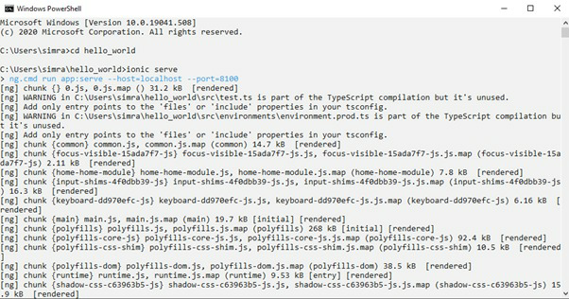

### 6. To access the web page go on http://localhost:8100

### Final Output :

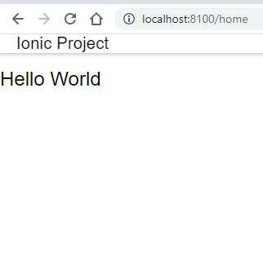

## *How to create and Ionic Android app:*

### Steps to create an ionic android app:

### After you have built the web app next command you should type is ionic cordova platform add android .This will add and android platform to your web app directory.

### 2. Now type ionic cordova build android to start building your android app.

### 3. Now type ionic cordova run android , If you have connect your machine to a phone and turned on USB debugging the app will export to your pc and if you are running an emulator the out will be like this.



 